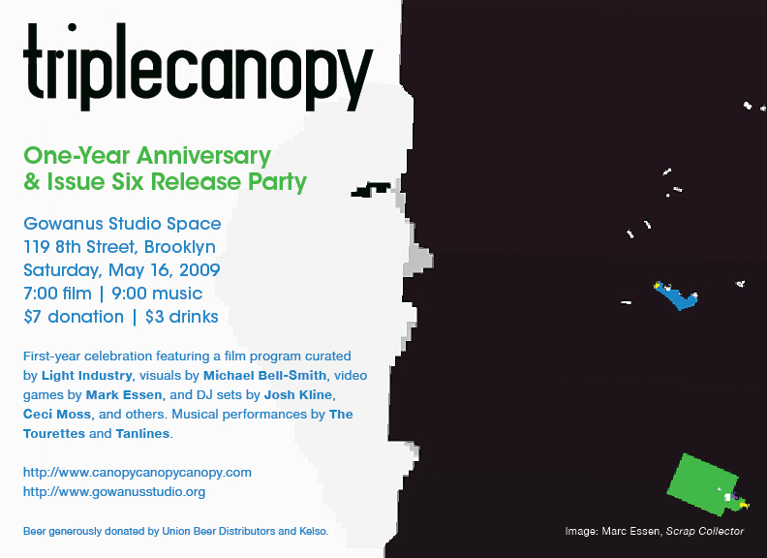

Press contact:
Peter J. Russo
peter@canopycanopycanopy.com
(240) 472 7260

Triple Canopy
One-Year Anniversary
& Issue Six Release Party

Gowanus Studio Space, 119 8th Street, Brooklyn, NY
Saturday, May 16, 2009
7:00 film | 9:00 music
$7 donation | $3 drinks

Featuring a film program curated by Light Industry, visuals by Michael Bell-Smith, video games by Mark Essen, and DJ sets by Josh Kline, Ceci Moss, and others. Musical performances by The Tourettes and Tanlines.

Beer generously donated by Union Beer Distributors and Kelso.

More info and Triple Canopy, issue 6: http://canopycanopycanopy.com

About Triple Canopy
Triple Canopy works collectively with writers, artists, researchers and other collaborators on projects that deal critically with culture and politics, and the ways people engage them, both online and in the world at large. These investigations are realized in an online magazine as well as in public programs and print publications encompassing various fields and locales. We aim to present work and advance ideas informed by a multitude of disciplines and perspectives, and to disseminate them among a broad and diverse audience. Triple Canopy was founded and launched in late 2007.

Thomas Beard and Ed Halter of Light Industry present Reductions. Created for home viewing, digest films transformed theatrical features into short subjects, bumping down the originals from 35mm to Super-8, often stripping them of color and sound, and re-editing the narratives into a concise ten to fifteen minutes, in the process changing their meaning in subtle, strange, and surprising ways. This selection includes a range of miniaturized movies, including Jerry Lewis vehicles, horror films, kung-fu pictures, and 70s disaster epics.

Michael Bell-Smith is an artist who uses digital forms to explore contemporary visual culture and the way in which it is mediated through popular technologies. His works have been shown in exhibitions at venues including the New Museum, Foxy Production, the Hirshhorn Museum, and the Museum of Modern Art. He lives in New York.

Mark Essen makes video games. Tonight he's showing Scrap Collector, a game about making money, and The Thrill of Combat, a game about flying a helicopter and collecting organs. Since 2008, his work has been featured in group exhibitions at venues such as the Museum of Contemporary Canadian Art in Toronto, Canada and Light Industry, Brooklyn. His work is currently on view at the New Museum of Contemporary Art, New York.

Josh Kline plays social-justice jams from the 80s and 90s, touching on homelessness, famine, and rampant inequality. Expect dance party mega-hits by Arrested Development, KLF, Crystal Waters, Public Enemy, Tom Tom Club, Inner City, and others who bummed out while getting down.

Ceci Moss plays the psychedelic-scientific explorations of 60s musicians who took stereo-channel panning over the edge, including Apryl Fool, Buffy Sainte-Marie and Harumi.

The Tourettes broke your heart nearly fifty years ago, when they came on the da-doo-ron-ron-core scene with their relatively flat hair and voices, and a boundless enthusiasm for a world you, as a sheltered and joyless Boomer teen, could have hardly imagined. Now that you've grown up, test the seams that you've carefully stitched around your heart as these surprisingly youthful-looking grandmas take the stage again, yelping and crunching and clapping through the wreckage of your adolescence.

Tanlines is Jesse Cohen (Professor Murder) and Eric Emm (Storm & Stress, Brothers production) playing electrified island sounds, synthesized live. Their first single, New Flowers, is out now on Young Turks.

Press contact:
Peter J. Russo
peter@canopycanopycanopy.com
(240) 472 7260
###

